SOFTWARE ENGINEERING

NAME:DHEERAJ S
SRN: PES1UG24AM429
CLASS:SECTION H

Code coverage
Before:
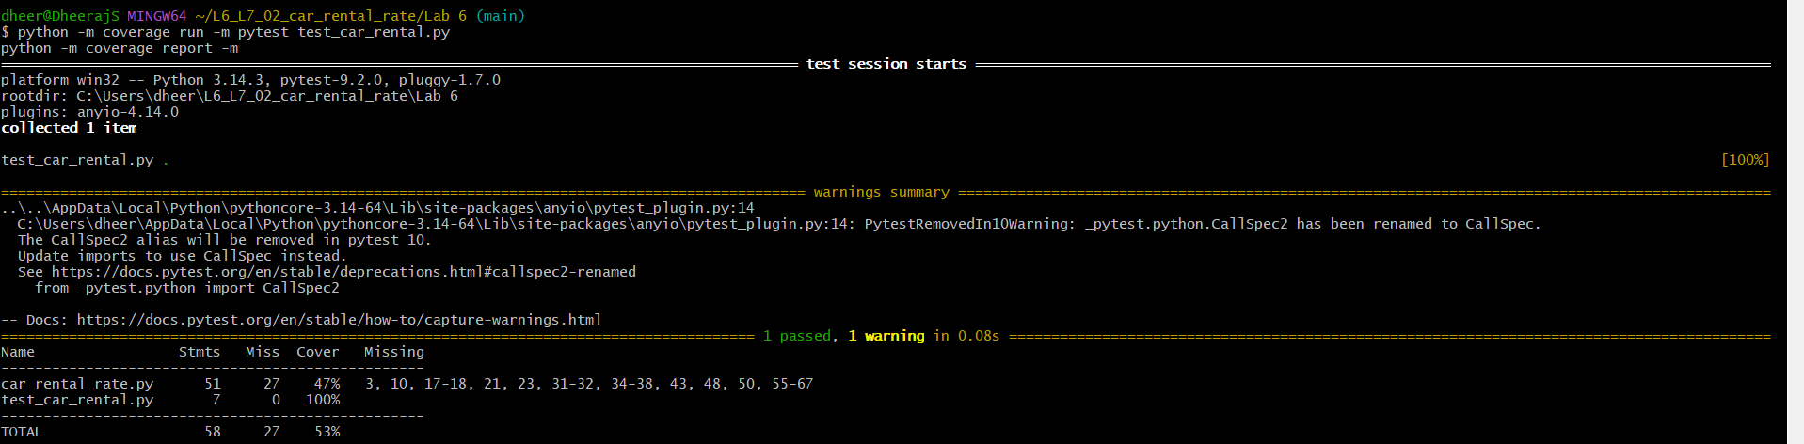

After:
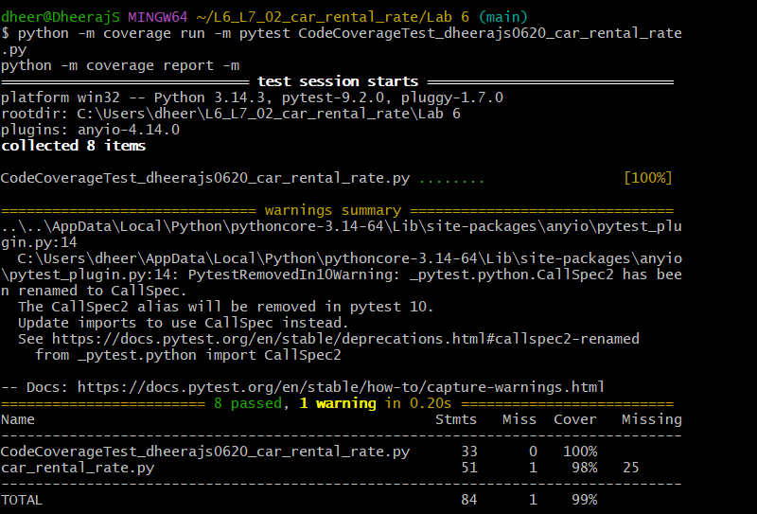

Branch coverage
Before:
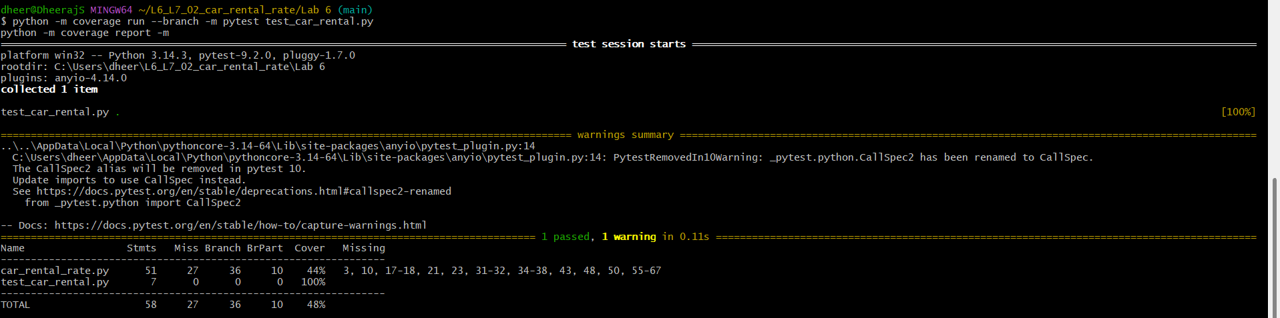

After:


